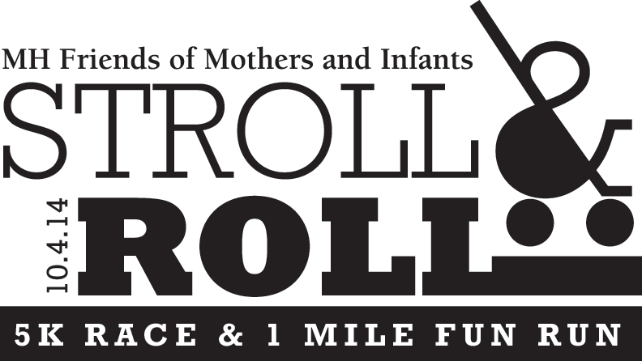May 2014

Dear Friend,

**We are off and running!** The **Stroll and Roll 5K race and 1 mile fun walk** is coming to your neighborhood on Saturday, October 4th, 2014.

Please join us as an official sponsor of the **2014 Stroll and Roll race.**

Your sponsorship will raise funds and community support for the MetroHealth Friends of Mothers & Infants, a nonprofit organization serving infants in need in the greater Cleveland area for over 35 years.

The Stroll and Roll will begin at Kamms Corner and wind its way through the tree-lined streets of beautiful Cleveland’s West Park neighborhood. In the spirit of supporting

**The Stroll and Roll provides your business with the opportunity to give back to the community and at the same time offers positive community visibility through race advertising on web sites, email blasts, signage and posters distributed around town and at other area races, and on the race commemorative T-shirt.** For details and benefits of all of the sponsorship levels please see the attached form.

**We will provide a table for your business to display brochures or any marketing material at the registration site and at the race event.**

Your sponsorship is greatly appreciated by the MetroHealth Friends of Mothers & Infants (Friends of M&I). Your support will also be recognized in the Friends of M&I’s annual report, on their website, and in their newsletter. Your donation will enable the Friends of M&I to provide strollers, portable cribs, clothing and diapers for the most vulnerable members of our community.

**To take full advantage of this opportunity, please submit the enclosed Sponsor Form as soon as possible to:**

**Lindsey McGowan**

**Attn: Stroll and Roll 5K**

**18921 Coffinberry Blvd**

**Fairview Park, OH 44126**

If you have any questions or would like more information, please contact me at the number below or call Lindsey McGowan at 440-520-4810.

We look forward to working with you. Thank you very much for your support.

Sincerely,



Stroll and Roll Race Committee

MetroHealth Friends of Mothers & Infants

*MetroHealth Friends of Mothers & Infants ● 4242 Lorain Ave. ● Cleveland, OH 44113 ● 216-957-9432 ● www.mothersandinfants.org*